Chapter 19, Problem 18.

Calculate the y parameters for the two-port in Fig.19.79.
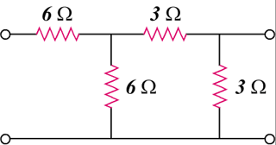

6 Ω

6 Ω

3 Ω

3 Ω

Figure 19.79
For Probs. 19.18 and 19.37.

